**BF[1] – Using Software Cortland Watson**

**Type in your score here 🡪 __41__ out of 41 points possible**

1. (5 points) Ponder/Reflect Exercise – Reflect on what you have learned from this portion of the class. Examples of what you can do are: a brief outline of material covered, insights you gained from class or personal study, or items you feel that you need to follow up or work on. (3-5 sentences)
   1. This week I learned how to use the basic factorial one way design to be able to find meaning in simple analysis. By doing this design we are able to see how we can control, and prevent error by randomization. It is really beneficial to be able to know how to use this design because we are able to use simple analysis to understand data.

2. Kudzu is a plant that was imported to the United States from Japan and now covers over seven million acres in the South. The plant contains chemicals called isoflavones that have been shown to have beneficial effects on bones. One study used three groups of rats to compare a control group with rats that were fed either a low dose or a high dose of isoflavones from kudzu. One of the outcomes examined was the bone mineral density in the femur (in grams per square centimeter). You would like to test if the mean bone mineral density is different for the three different groups. Use α = 0.05 level of significance.

*Check Requirements and Descriptive Statistics*

1. (1 point) What descriptive statistics would you use to describe the data (both numerical and graphical)? Please show the descriptive statistics.
   1. We need to see the mean scores. In this experimental design, we are testing the means and all is dependent on those. So favstats and histograms suffice.
   2. 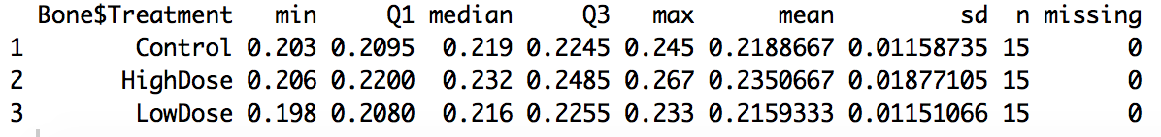
   3. 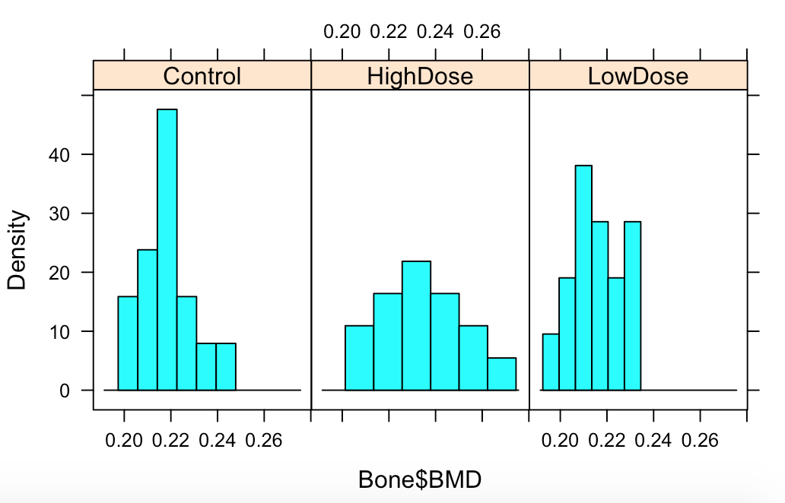
2. (1 point) Check the Requirement that the residuals are normally distributed.
   1. 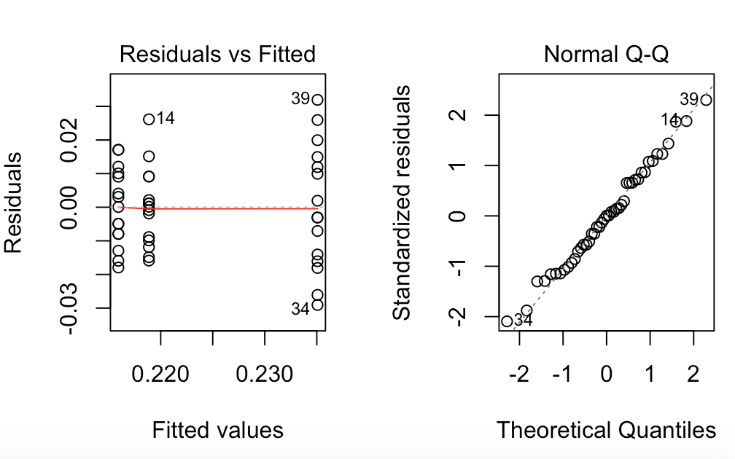
   2. 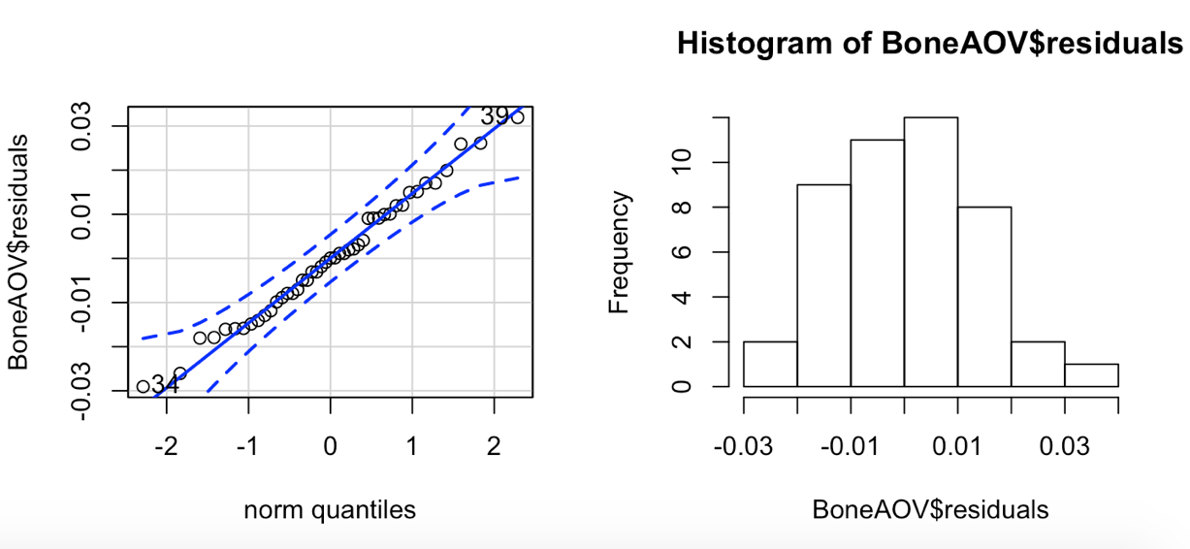
3. (1 point) Does the Requirement of equal standard deviations or variances hold? Why?
   1. Yes, the requirements hold. In the above graphics we are able to see that the data is normal and that the variance holds as well.

*Inferential Statistics*

1. (2 points) Write the appropriate null and alternative hypotheses.
   1. Null = The population means are equal.
   2. Alternative = At least one of the mean groups is different.
2. (1 point) Report the sample test statistic.
   1. 7.718
3. (1 point) State the P-value.
   1. 0.001
4. (1 point) What decision do you make based on the P-value and level of significance (α)?
   1. We reject the null and conclude that one of the means is different.
5. (1 point) State your conclusions in “layman’s terms”.
   1. We are able to see that the treatment that we give makes a difference on the response variable. Therefore, the treatment matters.
      1. USING R, do a complete analysis of variance comparing mean survival times for the cancer types. (For this exercise, do NOT log transform the data-just use the raw values.) For full credit, show the appropriate output.
   2. (2 points) Calculate and list the mean survival time in days for each cancer type.
      1. 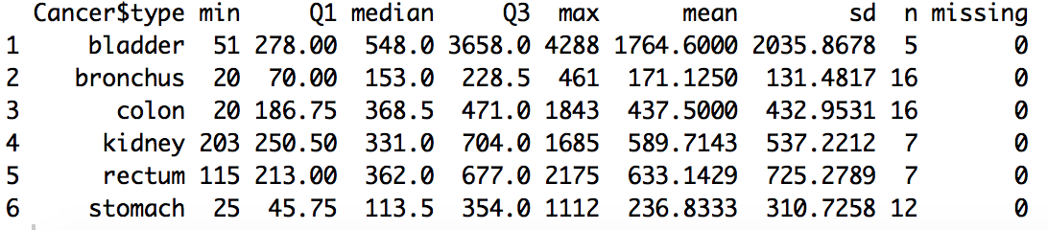
   3. (2 points) Check the requirements that the residuals are normally distributed and equal variances.
      1. 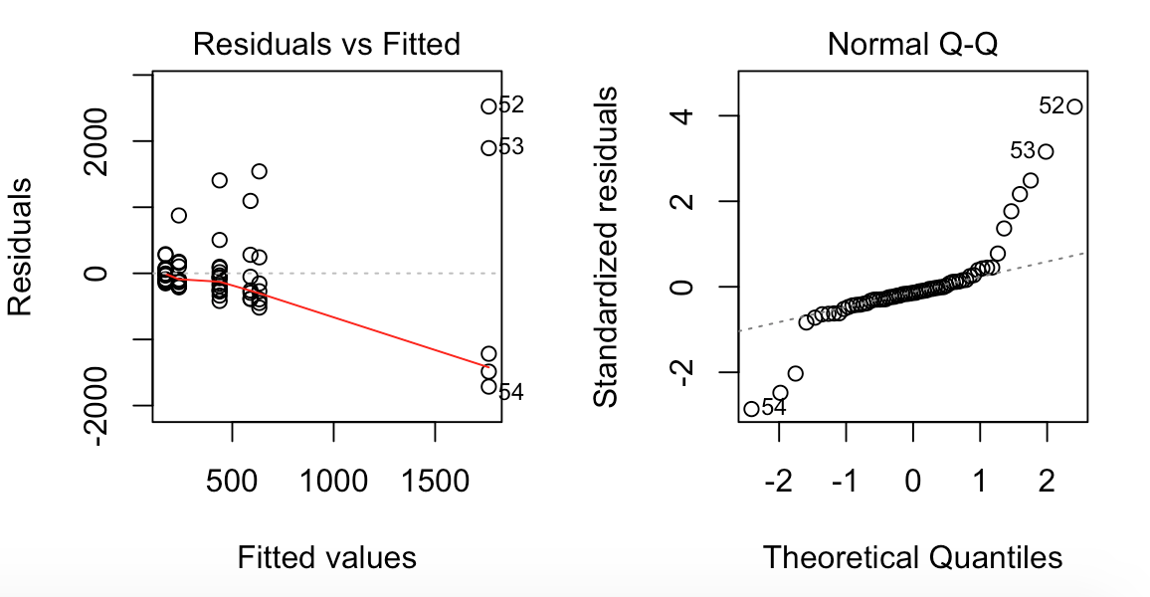
      2. Our requirements are not met. The variance is not even and the data is not normally distributed.
   4. (6 points) Test the hypothesis H0: All cancer types have the same mean survival time.
6. State the null and alternative hypotheses,
   1. Null = The population means are the same.
   2. Alternative = At least one of the means is different.
7. Give the ANOVA table
   1. 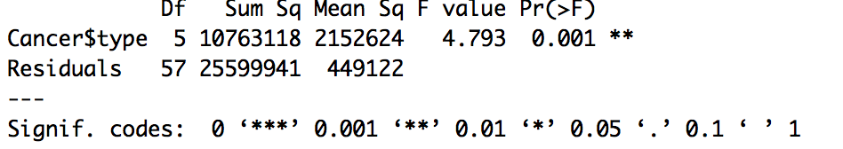
8. Give and Interpret the F statistic
   1. 4.793 This means that it is not likely chance that we found these results.
9. Give and interpret the p-value
   1. 0.001 This means that the results are significant and that we can reject the null hypothesis.
10. State the degrees of freedom for the F statistic,
    1. Num = 5
    2. Den = 57
11. Make a conclusion.
    1. We reject the null hypothesis and state that one of the means is different. This means that different cancers have different effects of the days.

4. USING R, do a complete analysis of variance comparing mean survival times for the cancer types. (For this exercise, USE the log transform the data.) For full credit, show the appropriate output.

(a) (2 points) Calculate and list the mean survival time in days for each cancer type using the log function.

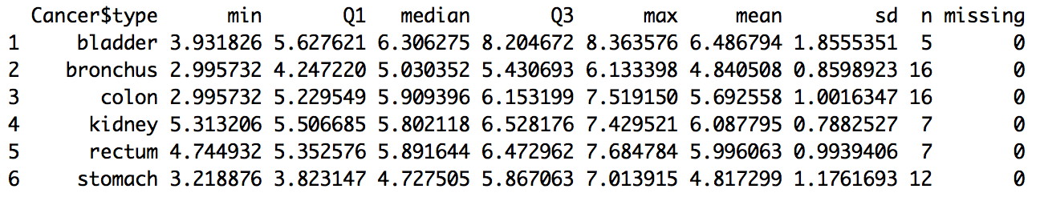

(b) (2 points) Check the requirements that the residuals are normally distributed and equal variances.

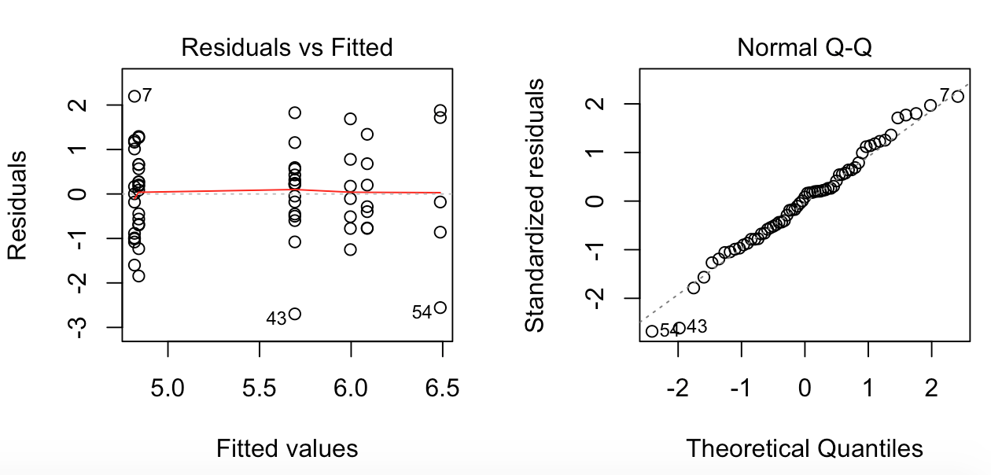

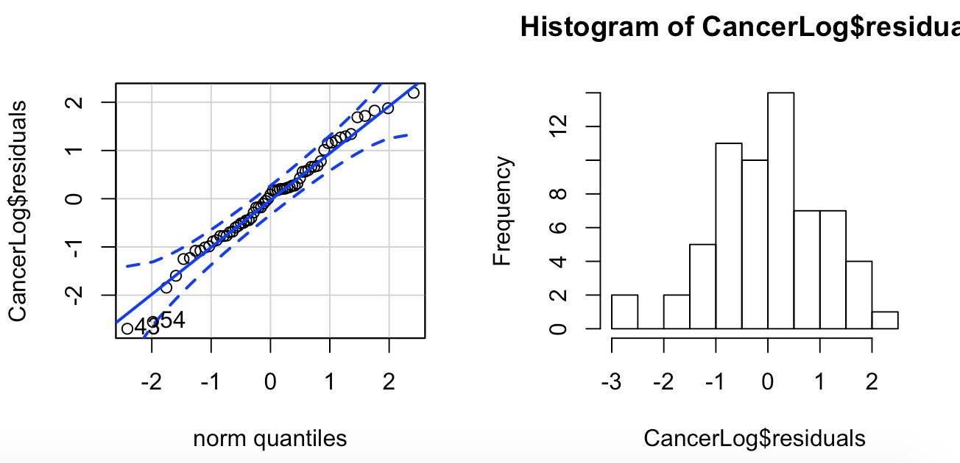

The transformation has made our data meet the requirements.

(c) (6 points) Test the hypothesis

H0: All cancer types have the same mean survival time.

1. State the null and alternative hypotheses,
   1. Null = The population means are the same.
   2. Alternative = At least one of the population means is different.
2. Give the ANOVA table
   1. 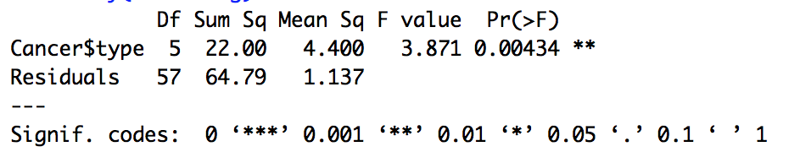
3. Give and Interpret the F statistic
   1. 3.871
4. Give and interpret the p-value
   1. 0.00434
5. State the degrees of freedom for the F statistic,
   1. Num = 5
   2. Den = 57
6. Make a conclusion.
   1. We rejet the null hypothesis and state that at least one of the population means is different.

(d) (2 points) Compare your results to problem #3. What are the similarities and/or differences?

In running the transformation we were able to control for unwanted variability. We were able to see that even if we were to make the data normal, then we would still find significance, or that the survival times are effected by the type of cancer. By running the transformation we control standard deviation and reign it in. This allows for us to see that even with the normalized data, we find significance.

(e) (2 points) What are the reasons we want to use replication (more than one unit per treatment group) in a study like this?

Replication is a huge part of any study. The more times that we replicate, the more accurately we will represent truth. In this given circumstance, many people react differently and have different experiences with cancer. One person could easily be an outlier, but replications bring it all together. Replications help us control for error.